**Friday 9th June 2023**

**This Half Term’s Value: Curiosity**

‘**Phrases of Faith’**

**Proverbs 25: 2-3:** It is the glory of God to conceal things, but the glory of Kings is to search things out.

**Psalm 119:105:** Your word is a lamp to my feet and a light to my path

Dear Parents/ Carers,

As we start the new half term we also turn our attention to our final value of the year, and it is fitting, seeing as our current Year 6 pupils are on the verge of starting their next big adventure, to look at our school value ‘Courage’.

You will see that we have renewed our ‘**Phrases of Faith’** for the new half term, and we will share these regularly as the term unfolds with our pupils.

In this first verse, we learn that God has wisdom and knowledge within his creation. Curiosity, when directed well, can lead to growth, wisdom, and a deeper relationship.

This second verse emphasises the significance of God’s Word in guiding our lives. It encourages curiosity about God’s teachings, as they serve as a light illuminating our path. By delving into His Word with a curious heart, we gain wisdom, understanding, and direction for our lives. The more we explore and discover, the better equipped we become to navigate the challenges we face.

And this week in particular has not been without its challenges! Our School, received a 2-day inspection with Ofsted. I could not be prouder of the way in which the whole school community conducted itself and of the way in which our wonderful children spoke. They were confident, knowledgeable and above all welcoming to our visitors. I Would like to extend my heartfelt thanks to members of staff across the federation, as well as to our Governors and to all those who helped to ensure the process went as smoothly as possible!

I wish you all a wonderful weekend.

With all best wishes,

Mrs S. Henney

**Attendance**

This week’s winners are Lawley – Well done!

|  |  |  |
| --- | --- | --- |
| **Class** | **This week …** | **Previous week ….** |
| Lawley | 97.92% | 96.52% |
| Wrekin | 89.47% | 96.84% |
| Caradoc | 92.61% | 95.65% |
| Stiperstones | 83.57 | 97.69% |
| Whole School | 91.88% | 96.54% |

**This week’s Star Pupils!**

This week’s pupils of the week are:

**Ercall** – Hughie for trying really hard in Nursery this week – well done Hughie.

**Lawley** - Amber for her hard work in literacy, she has been working hard on her sentence writing and making sure that she includes capital letters, finger spaces, full stops and uses her phonics knowledge with her spelling. Amber has also learnt to ride her bike without stabilisers. Well done Amber.

**Wrekin** – Connor - For demonstrating the school values in everything you do. Keep it up!

**Caradoc** - Matilda for amazing descriptive writing this week! Well done!

**Stiperstones** – We have awarded Logan our value award for showing 'Integrity'. Logan always shows behaviour of the highest standard; he works hard and shows enthusiasm for all that he does. He also demonstrates kindness to others and is a great role model to the younger children in the school. excellent attitude Logan!

**Class News**

**Ercall**

Welcome back everyone, we hope you enjoyed the half-term break.

We are having a wonderful week in nursery.

In literacy this week we have begun our new pathways to write topic which is, 'Supertato'.

The children have explored our farm which was set up to teach them where our food comes from.

All children took part in planting potatoes and carrots this week.

In provision our challenge was to help free the peas from the ice....the children used spoons and tweezers to help the peas escape- fantastic effort everyone! We explored lots of rich vocabulary throughout the activity too!

During phonics we have explored the end sound in words, 'ck' such as 'lock, tick, duck and neck'.

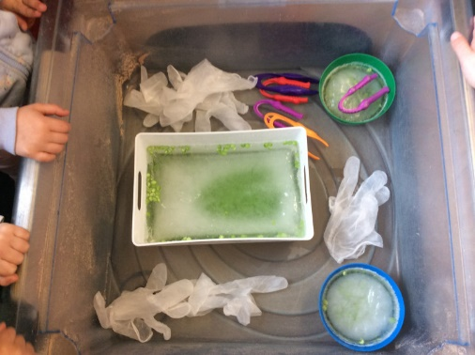In maths this week we are exploring number and counting. The children have been building potato towers, counting carrots and potatoes, exploring potato printing- including colour mixing using primary-coloured paints.

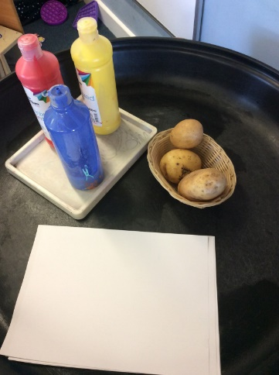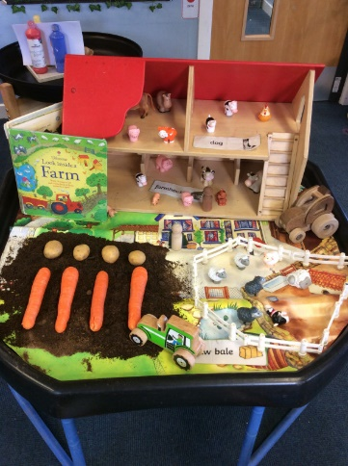Well done nursery, you are all superstars!

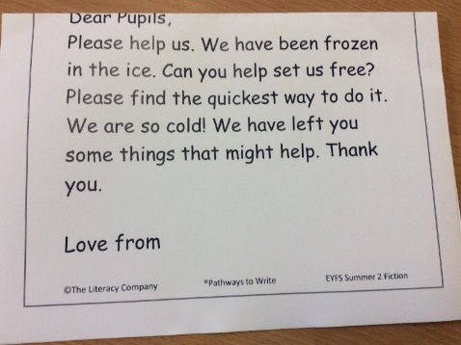

**Best wishes, Mrs Butler, Mrs Arblaster, Miss Hughes, Mrs Jones and Miss Sanders.**

**Lawley**

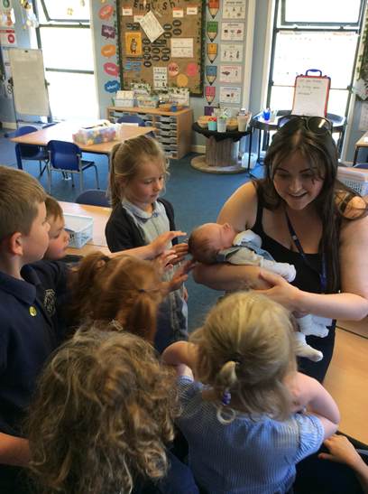This week, we got to meet the newest member of Lawley Class. The children were very excited to meet baby Wilf. We were very careful not to wake him and all told Mrs Greenway how much we missed her.

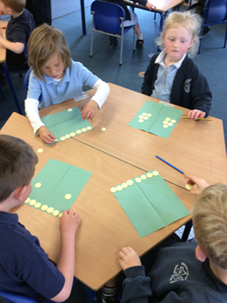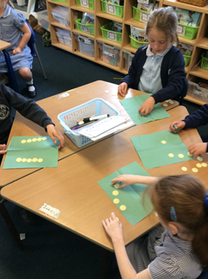

In our maths this week we used chocolate buttons to help us with our halving skills, we made sure that each half was equal and the chocolate will definitely help us to remember our doubles! Carrying on with the food theme we have also been trying lots of different fruits to help with out fruit senses poem in literacy.

Next week, year 1 children will be completing their phonics screening check. This will be taking place throughout the week during their guided reading sessions with Mrs Rawstorne. We have been doing lots of work practicing blending our alien words in lesson and provision. Your child will also be bringing home a practice sheet with their reading book to have a look through over the weekend.

**Mrs Rawsthorne**

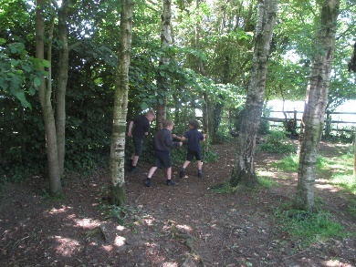

**Wrekin**

On Monday we headed outside to look for living and non-livings things as part of our new Science unit. We explored different natural resources and discussed that some things that are non-living used to be living and some have never lived.

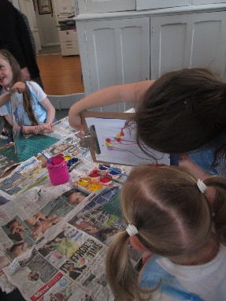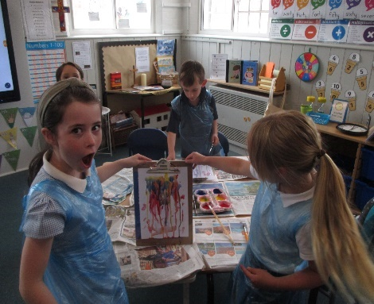In Art we are exploring colour and mixed media. This week we recapped what a primary and secondary colour is. We used water to help run colours together to make new ones.

We have created some fantastic hedgehog poems this week, which will lead on to writing our own wildlife poems. Check out our page on the website to see some examples.

Well done to all of Wrekin who represented our school impeccably during the inspection earlier this week.

**Miss Jones, Mrs Burns**

**Caradoc**

What a busy first week back for Caradoc! We started the week with a visit from 'A Bugs Life' workshop. The children learnt all about our local wildlife and how important they are for us. They spent time identifying various plants and insects around school and then had a fantastic time making a flower bed, a new pond and decorating rocks. It was a really lovely morning, and the children got a lot out of it.

In English, we started our new book 'Blue John'. The children are already really enjoying this story and we have begun to learn lots about caves!

In Maths, the children have begun to look at angles and shapes and we had lots of fun making obstacle courses for each other to travel along using mathematical language.

In DT the children began to think about electrical circuits and were successful in creating their own.

Another successful first week! Well done Caradoc!

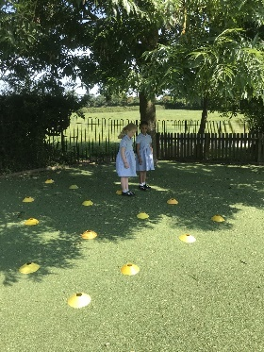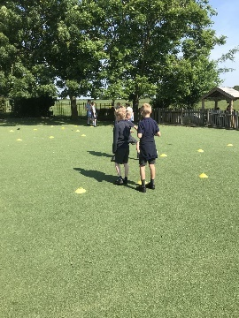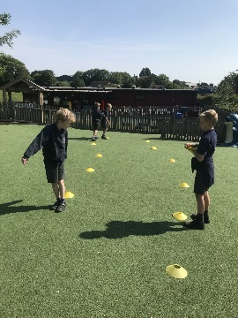

**Miss McLaughlin**

**Stiperstones**

Stiperstone class enjoyed the beginning of this half term taking part in the Bug Life worskhop. We enjoyed working in different groups with the children from Adderley to look around our school environment and identify the different plants. We then worked together to create a flower garden, started to create a brand-new school pond, painted rocks to help decorate the garden and made some signs.

We have also started our new Mayan topic with Mr Lockhart,and are looking forward to finding out even more about this civilisation throughout this half term. We have started off by finding out about the chronology of the Mayans and looking at where they lived in the world. We have thought about how different their lives might have been - not only to our own modern day lives but to other periods in history that we have learned about- such as the Anglo-Saxons.

We are really looking forward to heading to Arthog next week-it's sure to be a fun and action-packed week. I know we have lots of exciting activities in store for us when we are there!

**Mrs Baillie and Mrs Jones**

***other news ….***



**Sunhats and Sun Cream**

As the weather is getting warmer can you please ensure that you apply sun cream to your child before they come to school/Nursery. Children should also bring a sun hat to wear during break and lunchtimes.

**Eco-council**

We have put everyone's ideas together to submit our entry for the school garden competition. Have a look at our final design on the eco-council page on the school website! Shortlisted designs will be shown at Shrewsbury Food Festival and voted for by members of the public. You can purchase tickets for the show here: <https://www.shrewsburyfoodfestival.co.uk/morris-school-garden>

On Thursday the 15th we will be holding our lunchtime litter pick for everyone to join in with and after school, families are welcome to help us with a clear around the Millennium pond between 3.15 and 4.15pm. All children must be accompanied by an adult. Equipment is provided but feel free to bring your own too.

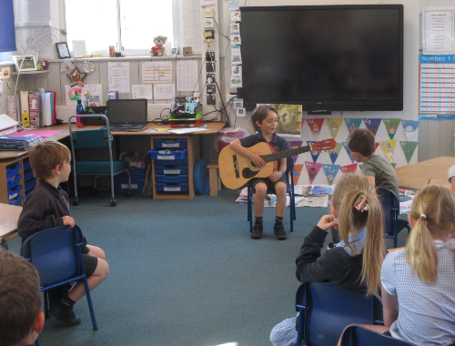**SMSC Update**

Our children are always encouraged to share their interests, hobbies and talents. This week Wrekin class were treated to an unplanned mini concert from Nicholas. He has been learning to play the guitar at home and lessons in school and was able to play for us all today. Fantastic!

**Gardening Club**

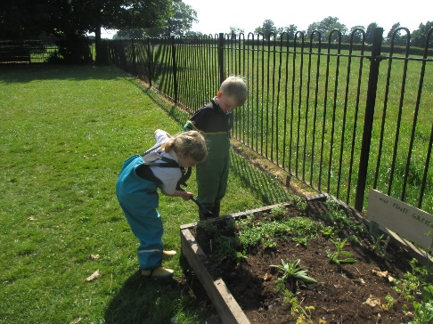

What an exciting week as we were able to do our first harvest! It was like hunting for buried treasure as we turned out our potato planter and started finding potatoes. We planted a reliable variety called Rocket which gave us some tiny but tasty early potatoes. The dry conditions made for a small harvest, but everyone got to pick 5 potatoes to bring home.

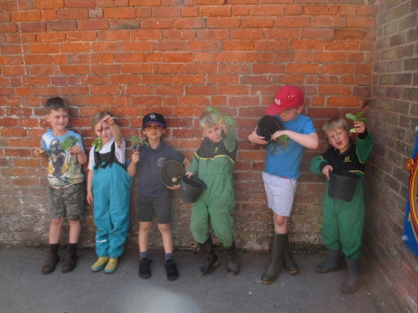

We also picked some of the ready radishes and discovered the leaves are spikey and sting a little. Lastly we had just enough time to water the newly planted pollinators raised bed (created during the BugLife workshop) and repot our lemon balm plant. With any luck there will be peas next week and runner beans at the end of June.

**Mrs Truman and the Gardening Club**

**Moreton Say Diary Dates 2022 – 2023**



**JUNE**

**Monday 12th June – Tempest Photography in School (Whole school and Yr6)**

Wednesday 21st June – Sports Day 9.15am

Thursday 22nd June – Nursery Sports Day – 2.00pm

Thursday 29th June – Grove School Open Evening 5.30pm – 8.00pm

**JULY**

Monday 3rd July – Thomas Adams Year 6 Move Up Day

Tuesday 4th July – Thomas Adams Year 6 Move Up Day

Wednesday 5th July – Back up Sports Day – 9.15am

Wednesday 5th July – New Parents Evening – 5.30pm

Monday 10th July – Grove School **Year 6** Move Up Day

Monday 10th July – Moreton Say Move Up Day

Tuesday 11th July – Grove School **Year 6** Move Up Day

Friday 14th July – PTA Summer Fayre (details to follow)

Tuesday 18th July – Grove School **Year 5** Visit Day

Wednesday 19th July – Year 6 Leavers Church Service – 9.15am (parents welcome)

Thursday 20th July – Year 6 Leavers Performance – 2.15pm

**and finally….**



